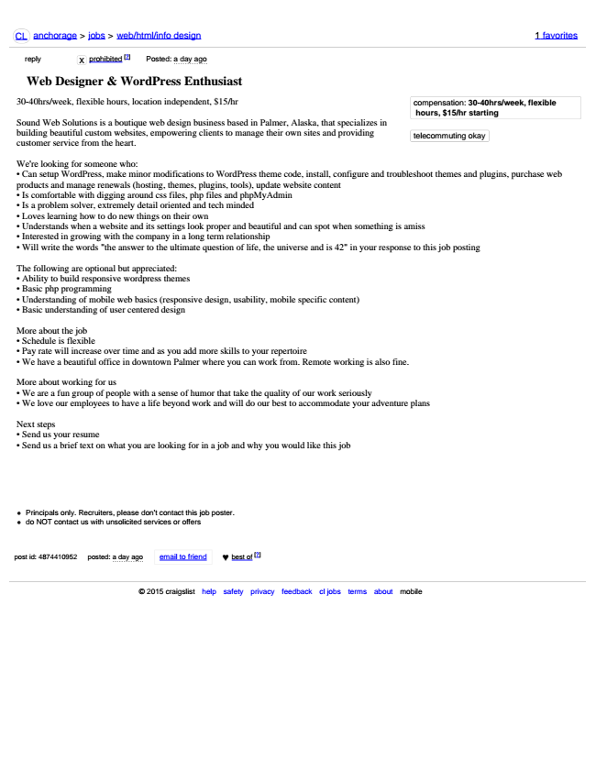

CL anchorage > jobs > web/html/info design 1 favorites

reply reply

x prohibited [?] Posted: a day ago

**Web Designer & WordPress Enthusiast**

30-40hrs/week, flexible hours, location independent, $15/hr

Sound Web Solutions is a boutique web design business based in Palmer, Alaska, that specializes in building beautiful custom websites, empowering clients to manage their own sites and providing customer service from the heart.

We're looking for someone who:

• Can setup WordPress, make minor modifications to WordPress theme code, install, configure and troubleshoot themes and plugins, purchase web products and manage renewals (hosting, themes, plugins, tools), update website content

• Is comfortable with digging around css files, php files and phpMyAdmin

• Is a problem solver, extremely detail oriented and tech minded

• Loves learning how to do new things on their own

• Understands when a website and its settings look proper and beautiful and can spot when something is amiss

• Interested in growing with the company in a long term relationship

• Will write the words "the answer to the ultimate question of life, the universe and is 42" in your response to this job posting

The following are optional but appreciated:

• Ability to build responsive wordpress themes

• Basic php programming

• Understanding of mobile web basics (responsive design, usability, mobile specific content)

• Basic understanding of user centered design

More about the job

• Schedule is flexible

• Pay rate will increase over time and as you add more skills to your repertoire

• We have a beautiful office in downtown Palmer where you can work from. Remote working is also fine.

More about working for us

• We are a fun group of people with a sense of humor that take the quality of our work seriously

• We love our employees to have a life beyond work and will do our best to accommodate your adventure plans

Next steps

• Send us your resume

• Send us a brief text on what you are looking for in a job and why you would like this job

Principals only. Recruiters, please don't contact this job poster. do NOT contact us with unsolicited services or offers

post id: 4874410952 posted: a day ago email to friend ♥ best of

© 2015 craigslist help safety privacy feedback cl jobs terms about mobile

**compensation: 30-40hrs/week, flexible**

**hours, $15/hr starting**

telecommuting okay

[?]